SECJ 3403 Special Topic in Software Engineering

Sem 2 2021/22

INSTRUCTOR: DR. Shahliza bt Abd Halim
shahliza@utm.my

3/6/2022: Database
There are 2 different types of databases which are relational and non-relational databases
i. Relational database service which is surported by Amazon RDS currently supports six relational databases engines: MySQL, Amazon Aurora, Microsoft SQL Server, PostgreSQL, MariaDB, and Oracle.
ii. Non relational managed database are Amazon DynamoDB
iii. AWS purpose-built database services: Amazon Redshift and Amazon Aurora
- Lecture Notes <<ppt>>
- Group Activity: <<jamboard>>
- Lab for this week <<all labs will be in AWS Learning Academy >>
i. Lab Database - refer to Lab 5 - Build a Database Server

Lab Reflection template : Use the same template distributed in team chat
Exit Ticket : URL will be given in general chat Discord

Notes:
Bandwidth vs Throughput
Database Sharding

INSTRUCTOR: DR. Shahliza bt Abd Halim
shahliza@utm.my

14 May 2022: Automatic Scaling and Monitoring
Lecture Notes <<ppt>>

- Lab for this week <<all labs will be in AWS Learning Academy >>
i. Lab Autoscaling- refer to Lab 6 - Scale & Load Balance your Architecture
- Architecture before lab

- Architecture after lab
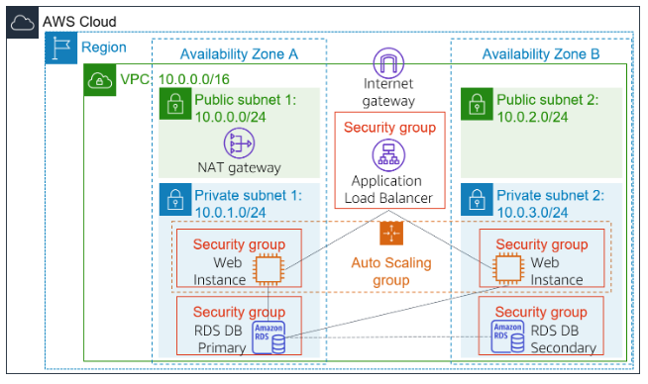

Lab Reflection template : Use the same template distributed in team chat
Exit Ticket : URL will be given in general chat Discord

